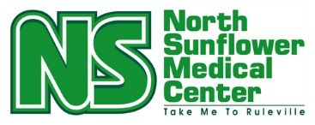
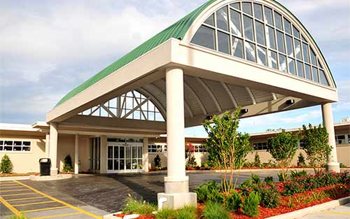
Community Needs Assessment
2025

2025 Community Needs Assessment
Table of Contents
NSMC Overview: 3
Demographic Information about Market Area 4
Additional Info about NSMC 6
Health in Sunflower County 11
Economic Impact: NSMC 18
NSMC Services: 21
Medical Staff: 22
Community Needs Assessment Survey 23
Summary of Findings 28
Strategic Initiatives Moving Forward 34
References 35
Acknowledgements 36

NSMC Overview:
North Sunflower Medical Center is a 25 bed Critical Access Hospital (CAH) with a 60 bed Long Term care Unit, located in Ruleville, MS. NSMC offers a wide range of services to a service area which includes five counties in the Mississippi Delta. North Sunflower Medical Center has a surgical unit and a large complement of outpatient services including the Sunflower Rural Health Clinic, located on the main hospital campus, which is operated from 8:00 am until midnight, Monday through Friday, and 8am to 8pm Saturday and Sunday.
North Sunflower recognized the need for expanded access to care as early as 2005, when the Sunflower Rural Health Clinic moved from a location adjacent to the rear of the campus to a new building located at the front of the present-day campus. Hours of operation were extended from a traditional 8:00 am to 5:00pm format to seven days a week with the hours you see above; 16 hours during the weekday, and 12 hours each day on the weekend. These hours of operation remain today, making Sunflower Rural Health Clinic the only clinic in our region to maintain this level of access.
Additional access to care issues were addressed with collaborations between metro (Jackson) specialty clinics and the rural health clinics. Among these collaborations are a cardiac clinic weekly, a sports medicine orthopedic specialty clinic once weekly, a plastic surgery clinic monthly, a urogynecologist monthly, and a fulltime board-certified Pulmonologist on campus. Telehealth services expanded during the COVID-19 pandemic, in the rural health clinic, and remain an important part of the strategic plan for enhanced access to care today.

Swing-bed services also expanded with a full complement of rehabilitation professionals including access to Physical Therapy, Occupational Therapy and Speech Therapy seven days a week inpatient and Outpatient PT, OT and ST available 5 days weekly.
A diagnostic center was created in downtown Ruleville with a state-of-the-art digital mammography unit available, along with women’s health services and a med-spa line of available
therapies. North Sunflower Cosmetics was added in 2021 with additional services such as skin resurfacing, cosmetic fillers, and Botox therapies available.
A pulmonology specialty clinic was also established in 2021 with the addition of a fulltime pulmonologist, who has been associated with the North Sunflower Sleep Study Center for over a decade. A new Pulmonary Functioning Test (PFT) unit was added shortly afterwards to enhance pulmonary services and expand access to pulmonary specialty services in the Mississippi Delta.

Demographic Information about North Sunflower Medical Center’s Market Area

North Sunflower’s primary market area has been determined to be comprised of a six-zip code area extending from Bolivar County on the west side to Tallahatchie County on the east side, and to the northern part of Sunflower County to the southern part of the north sunflower hospital district.
In North Sunflower’s secondary market area, there is a Short-Term Acute hospital located approximately ten miles away. Both hospitals share markets and have chosen to work cohesively rather than in competition with each other, which benefits the rural communities we each serve.
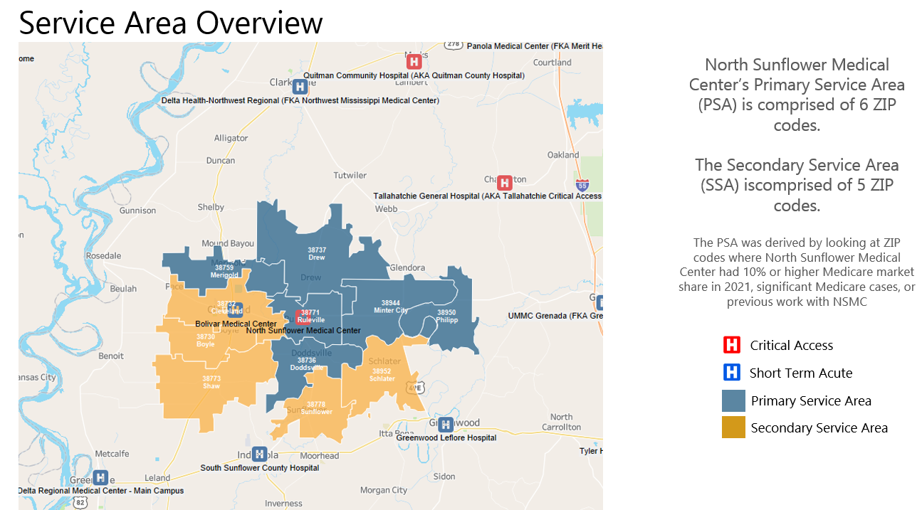

Historically agriculture has been, and remains the primary business in the Mississippi Delta region, although with the mechanization of the farming industry in the 1930’s, there was a great out-migration of the farm labor population. This has affected the population of many of the small rural towns and continues to affect them today. The lack of industry, weak education systems, and closure of some of our rural hospitals has caused some of the delta towns to nearly collapse.
The community North Sunflower serves includes a disproportionately high number of impoverished individuals who are either uninsured or under insured. The 2020 census shows our community as being one of the lowest per capita incomes in the state with one of the highest persons who live in poverty in the nation at 34.8%.
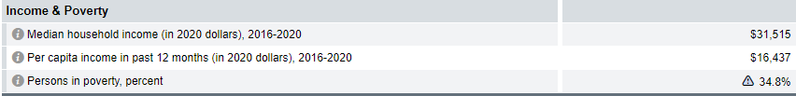

The state of Mississippi has a poverty rate of 18.7% which is high all by itself, but it is compounded by generational poverty here it the Mississippi Delta.
North Sunflower Medical Center is a vital, growing organization with a dedicated staff of highly trained professionals ready to embrace the challenges our diverse population has to offer. Most of our staff live here in the Delta, and fully understand the culture; its wonderful rich heritage, and the crushing poverty and challenges it brings.

Additional Information about North Sunflower Medical:

Excerpts taken from the 2018 MHA “Rural Hospital of the Year” award and the 2017 MNA “Nightingale Rural Hospital of the Year Award”
- North Sunflower County Hospital opened October 9, 1950 with 19 patient rooms and a total staff of 15 members, plus 6 physicians
- North Sunflower County Hospital was built to provide hospital services for the citizens of the area and for all who came through its doors, regardless of their ability to pay. It also encompassed the first hospital-based home health agency in the state.

In 1955, the first additions to the hospital were made to add additional patient rooms and remodel. In-room bathrooms were built to replace the central bath. The Acute Care Unit was expanded in 1963 to a total of 15 acute care beds. In 1972, renovation and modernization occurred and increased the number of hospital bed to 31. In 1974 improvements were made with establishment of a Coronary Care Unit, a dietary corridor, improvements to Outpatient, Laboratory and Radiology departments, as well as expansion of the surgical and obstetrical suites. The total footage of the hospital was increased to 44,000 feet.

In 1977, Station C (Walter B Crook Nursing Facility) was constructed and opened in 1989. Further construction occurred in 1994 to add 4 additional nursing home rooms,

Administrative offices, and a facility dining room. The number of beds in Walter B Crook Nursing Facility was increased to 41 and the addition of an Alzheimer’s wing in 1998. Walter B Crook Nursing Facility currently has 60 private patient rooms for residents.

North Sunflower County Hospital became designated as a Critical Access Hospital, changed its name to North Sunflower Medical Center in 2004, and began increasing access to care and expanding its services to the community. In 2007, North Sunflower Medical Foundation was formed and serves as the philanthropic arm of North Sunflower Medical Center, providing a separate non-profit entity aimed at supporting and improving healthcare in the Mississippi Delta.

In 2011, North Sunflower Medical Center opened the Beacon Wellness Center, a 33,000 square foot facility which houses the Surgical Wing, Administration, The Sleep Center, and a “state of the art” workout facility.

North Sunflower Medical Center is a diversified facility with services including a 25-bed Acute Care/Swing-bed Unit, a 60-bed Skilled Nursing Facility (Walter B Crook Nursing Facility), an Outpatient-Geri-Psych Program, Radiology Services (with MRI, a 64 Slice CT Scanner with Cardiac CTA Scan, and Ultrasound services), Durable Medical Equipment, Lab Services, GI Lab, Outpatient Cardiac Rehab, Outpatient Infusion Services, Outpatient Surgical Procedures, Sunflower Dental Clinic, Sunflower Eye Station, Sunflower Diagnostic Center, Nuclear Stress Testing, Specialty Clinic offering Cardiac, Orthopedic, Podiatry, Obstetric and Gynecologic, and Wound Care Services, as well as Sunflower Discount Pharmacy, Simply Sunflower (gift, flower, and scrub shop),

Sunflower Rural Health Clinic, and Sunflower Greenwood Clinic. North Sunflower Medical Center, with multiple service line providers employs over 500 people including physicians and Certified Nurse Practitioners.

- North Sunflower Medical Center has also sponsored the MNA conference, sponsored Key Note speakers for the conference, and had 2 of their employed RN’s participate as speakers for the educational offerings. North Sunflower Medical Center has been recognized and received the Outstanding Mississippi Small Rural Hospital Award for its tremendous strides in advancing rural health care in Ruleville and Mississippi.
- North Sunflower Medical Center supports RN participation in professional organizations by providing financial means through payroll deduction for organization dues, by sponsoring RN employees for the convention participation and continuing education, and by hosting 4 Mississippi Nurses Association (MNA) education seminars.
- North Sunflower Medical Center supports RN professional development by encouraging nurses to obtain certifications in specialty areas such as wound care, trauma, ACLS, PALS, CLNC, coding, auditing, infection control, and case management. Educational workshops are encouraged and provided. It encourages all knowledge advancement and has purchased a virtual skills lab that uses computer software that allows all nurses as well as physicians practice skills. Advancement in practice is also encouraged and supported for BSN and MSN. Tuition reimbursement is provided for mid-level providers.
- North Sunflower Medical Center recognizes RN employees as well as other employees through the Leadership by Example award as well as the First-Class Service STAR award each month. Individual RNs are recognized internally by their Nurse Managers and have been recognized previously by participating in the “Great Catch” program. They are recognized for participating in the DEU program and for mentoring Extern students and well as being Preceptors for students.

- North Sunflower Medical Center has RN participation in decision-making/management by including RN participation in all committees---Quality, Safety, Risk Management, Infection
- Control, Policy and Procedure, Pharmacy and Therapeutics, Utilization Review, and Spirit Squad. RN managers attend Medical Staff Meetings and Department Head Meetings. Nurse
- Managers participate in the hiring of employees for their units and may include other nurses as needed. Monthly meetings are held on the units with Administration and other Department leaders/employees participating as they are asked.
- North Sunflower Medical Center has demonstration of community support for nursing by both Foundation and hospital provided tuition and scholarships that are awarded. The Education Department (which includes nurses who work on different units and participate in new services) is frequently asked to participate in Health Fairs, talk to schools, and provide education to the public about services that are offered. On the other hand, North Sunflower Medical Center offers clinical rotation for multiple colleges: MDCC, Holmes, DSU, Coahoma, MUW, UMC, UT, and Walden University. It participates in the DEU program with DSU and Extern Programs through ONW. NSMC contributed to the salary of an additional clinical instructor for a local university to increase student numbers and decrease the number of students per instructor. North Sunflower Medical Center also co-sponsored “Music That Heals” at the Grammy Museum to further community awareness of care.
- North Sunflower Medical Center’s demonstration of leadership/management closely involves management, who promotes education in nursing and helps facilitate in the promotion of the nursing profession.
- North Sunflower Medical Center has had a long partnership with University Medical Center and its longstanding telemedicine program in the Emergency Department. It was also involved in the implementation of a patient-centered, multidisciplinary team approach for diabetic patients through care innovations and daily uploads of patients’ blood sugar results into the UMMC telemedicine portal and telemedicine endocrinology services. (Partners on this project included C-Spire, UMMC, Governor’s office, NSMC, and GE). This was an

outstanding learning experience and set the stage for future Diabetes Disease care within the Sunflower Rural Health Clinic.
It has participated in three documentaries, PBS (New York), FCC (Washington, DC), and The Digital Divide (New York) on the implementation of telemedicine in rural areas.
North Sunflower Clinic offered school based EPSDT screening and immunization, dental and vision screening services to thousands of children during the school year throughout the state via “Screen Teams” from 2012 until 2018. The dental “Screen Team” provided dental and oral cancer screenings to thousands of nursing home residents as well as providing education to nursing assistants on proper oral care from 2012 until 2018.
The Beacon Wellness Center offers “Healthy Eating” education, has offered “Financial Literacy” education as well as fitness programs for the community and employees. The Cardiac Rehab program in the Wellness Center uses state of the art monitoring equipment and employs a full-time Respiratory Therapist as well as a Certified Fitness Instructor. Multiple groups are conducted each day and the program stays full.

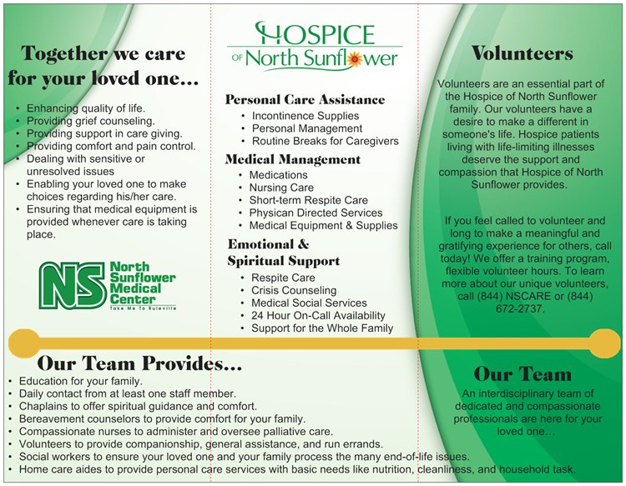

Health in Sunflower County:
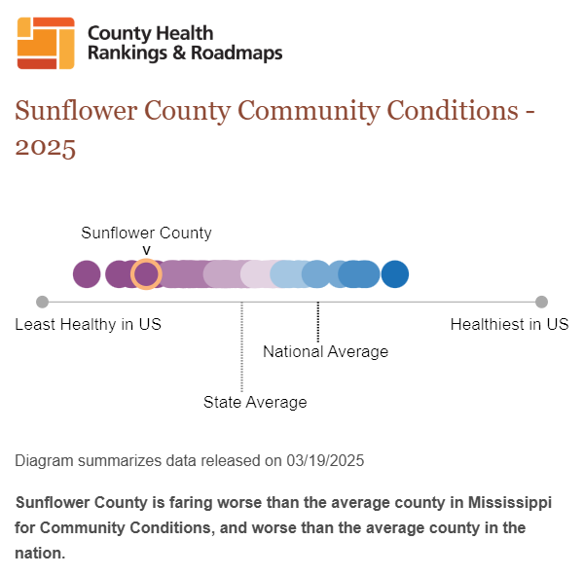
Reference: County Health Rankings (2025). Retrieved on the internet from: Sunflower,
Mississippi | County Health Rankings & Roadmaps

Health in Mississippi: Chronic Disease

Heart disease is Mississippi’s leading cause of death according to MSDH 2023 Report Health Card. Death from cardiovascular disease in Mississippi remains the highest in the nation. Mississippi ranks 2nd in the United States for the prevalence of diabetes, age-adjusted deaths from cancer, and obesity, which is trending down, among adults. Mississippi also ranks 6th in the U.S. for smoking among adults. Mississippi also has a high prevalence of high blood pressure (hypertension) which is a major contributing factor in the high number of Mississippians who are at risk for cardiovascular disease, heart attacks, strokes and kidney disease according to the MSDH (2025).

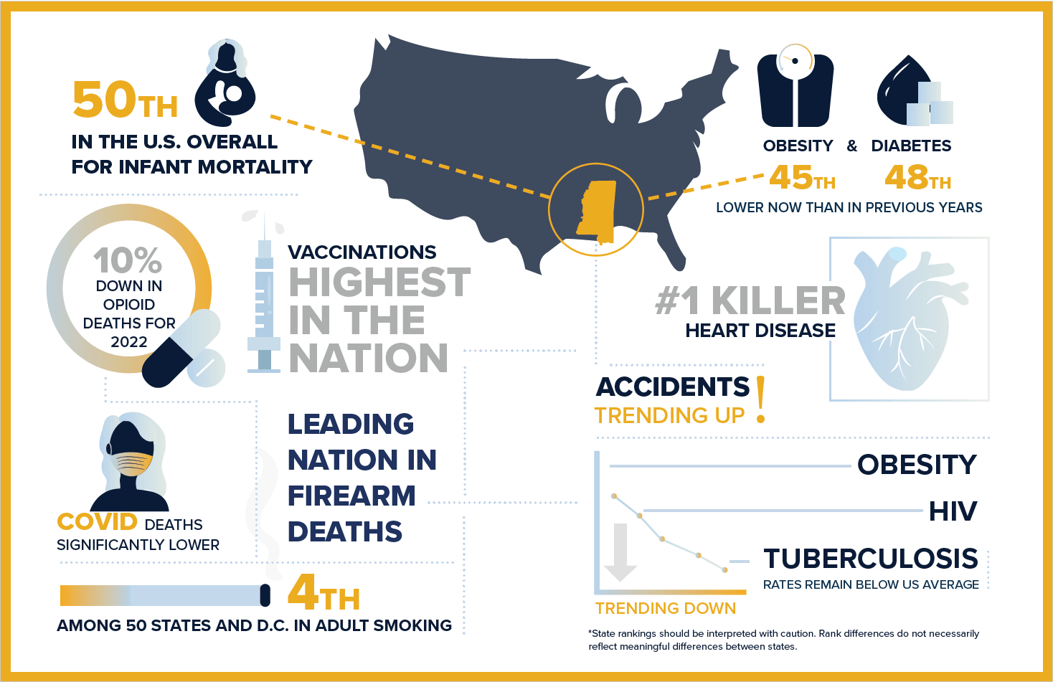
Reference: MSDH (2025) Mississippi Public Health Report Card 2023. Retrieved from the internet from: Mississippi Public Health Report Card 2023 - Mississippi State Department of Health
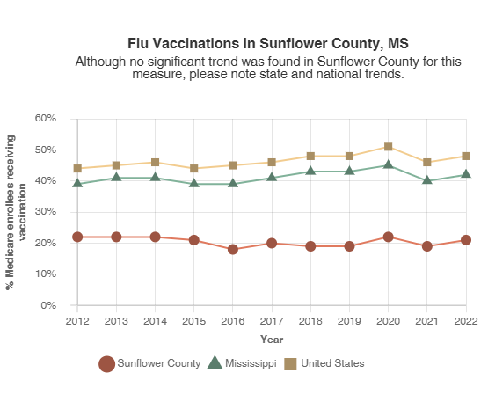Reference: County Health Rankings (2025). Retrieved on the internet from: Sunflower, Sunflower, Mississippi | County Health Rankings & Roadmaps

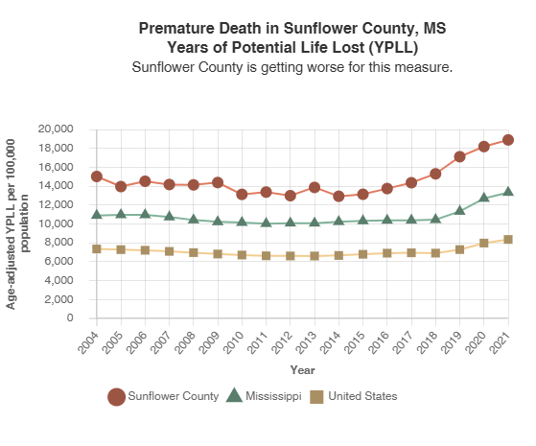Reference: County Health Rankings (2025). Retrieved on the internet from: Sunflower, Mississippi | County Health Rankings & Roadmaps

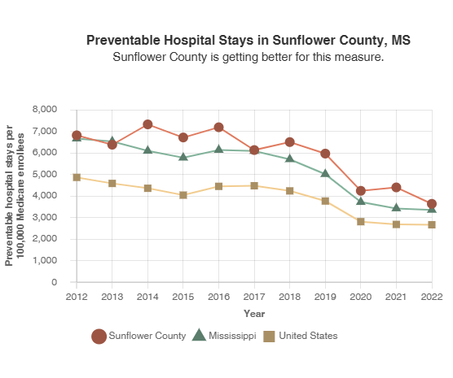Reference: County Health Rankings (2025). Retrieved on the internet from: Sunflower, Mississippi | County Health Rankings & Roadmaps

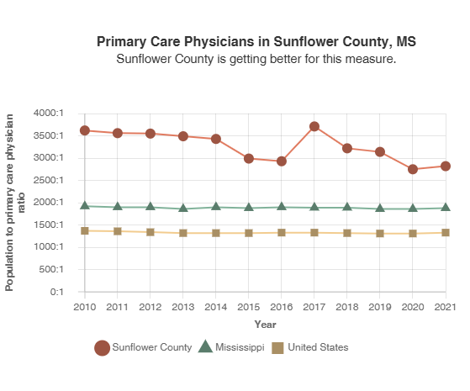

Reference: County Health Rankings (2025). Retrieved on the internet from: Sunflower,
Mississippi | County Health Rankings & Roadmaps

Leading Causes of Death

in Sunflower County, Mississippi
Leading Causes of Death Under Age 75 | Deaths | Rate per 100,000
Malignant neoplasms | 126 | 178.1
Diseases of heart | 114 | 161.2
COVID-19 | 79 | 111.7
Diabetes mellitus | 60 | 84.8
Accidents | 50 | 70.7
Source: CDC WONDER.
Center for Disease Control and Prevention. (2025) Underlying Cause of Death. Retrieved on the internet from: CDC WONDER
Leading causes of premature death are presented as crude rates (not age-adjusted). Crude rates show the true incidence of premature death within a county and are influenced by the underlying age distribution. For additional information please view the CDC WONDER Documentation.



Economic Impact Analysis
North Sunflower Medical Center is composed of:
- Critical Access Hospital (CAH)
- Sunflower Rural Health Clinic
- Sunflower Greenwood Rural Health Clinic
- North Sunflower Medical Center Pharmacy
- Haire Drug Center, LLC (Cleveland, MS)
- Sunflower-Greenwood Pharmacy
- Walter B. Crook Nursing Facility
- NSMC Durable Medical Equipment
- Diagnostic Center
- Hospice of North Sunflower
- NSMC Med-Spa
- Beacon Wellness Center
- Sleep Center
- Out-Patient Behavioral Health Clinic
- Cardiac Clinic
- Pulmonology Clinic
- Pediatric Clinic
- Infusion Center
- Cardiac Rehabilitation Center
- Simply Sunflower Gift Shoppe.
- Sunflower Boyle Clinic (Opening 2026)

North Sunflower Medical Center directly employs 548 FTE employees, 18 PT employees and 90 PRN employees. In 2025, NSMC paid out annual payroll and retirement benefits totaling $37,960,601. North Sunflower Medical Center pays out (on average) $450,000-$550,000 per year in medical benefits for employees and their families.

Healthcare and social assistance make up 18.4 % (2024 Data) of Sunflower County’s employment by industry (Sunflower County). Based on that percentage and the total number of healthcare workers in the county being 1,619 (Sunflower County, 2024 Data), which grew North Sunflower Medical Center employees 35% of the healthcare workers in the county.

Approximately 40% of the FTE employees working at North Sunflower Medical Center reside in Sunflower County and directly impact the economy in this area through employment opportunities, compensation, and health benefits.

“When not-for-profit hospitals address socioeconomic issues in the communities they serve, they help residents to afford health insurance, reduce costs due to preventable and chronic conditions, and support their own workforce needs. Building community wealth improves the ability of local-residents (who are likely patients) to pay for care. Further, attending to the social determinants of health can prevent or significantly reduce the management cost of chronic conditions such as diabetes, which disproportionately affects low-income individuals” (Samuelson, 2017).

28.9% of Sunflower County’s population live below the poverty level as of 2024 data. The federal poverty level in 2025 for a family of four is $32,150 (HHS, 2025) (Federal Poverty Level (FPL) – glossary). The average salary paid to full-time employees is $50,405, implying North Sunflower Medical Center contributes significantly to raise the poverty level in the community.
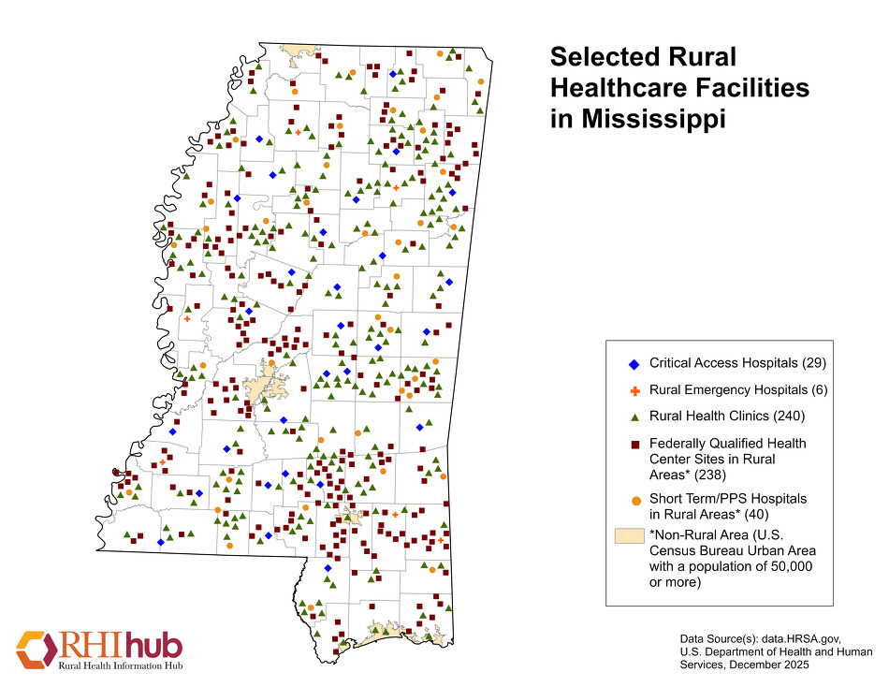

NSMC Services:
Acute Care | Behavioral Health Services | Cardiology | Emergency Services
Retail Pharmacy  (2) Locations | Hospice of North Sunflower | Inpatient Rehabilitation | Laboratory
Medical Foundation | North Sunflower Cosmetics | MS Center for Advanced Medicine | NSMC Pharmacy
Nuclear Stress Testing | One Call Referral Line | Outpatient Cardiac Rehabilitation | Outpatient Infusion Services
Outpatient Rehabilitation | Pediatrics-Sunflower Rural Health Clinic | Pulmonary & Sleep Medicine | Radiology
Southeast Urogyn | Simply Sunflower | Sunflower Rural Health Clinic | Sunflower Diagnostic Center
The Beacon Wellness Center | The Sleep Center | Sunflower Med Spa | Sunflower Medical Equipment
Surgical Services | Telehealth | Walter B. Crook Nursing Home | Wound Care Services

NSMC Medical/ Clinical Care Staff:
# of providers | Areas of Care
4 | Emergency Medicine
1 | Ear, Nose & Throat (ENT)
6 | Family Practice Physicians
2 | General Surgeons
1 | Gynecologist-Surgeon
1 | Maxillofacial Surgeon
1 | Psychiatrist
1 | Radiologist
1 | Pulmonologist
1 | Pathologist
1 | Pediatrician
1 | Pediatric Dental Surgeon
1 | Podiatrist (DPM)
7 | Registered Pharmacists-Pharmacy
11 | Nurse Practitioners

Specialty Clinic Providers:
# of providers | Areas of Care
3 | Jackson Heart Clinic  Interventional Cardiology
3 | Mississippi Center for Advanced Medicine  Pediatric Specialist
3 | Mississippi Sports Medicine  Orthopedics
1 | Mississippi Premier Plastic Surgery  Plastic Surgery

Community Needs Assessment Survey:
A community needs assessment was conducted using convenience sampling in 2025-2026 by utilizing electronic APP technology via cell phones. The survey was sent to Sunflower Rural Health Clinic patients by requesting their responses to the assessment instrument. The Sunflower Rural Health Clinic treats a diverse group of patients from across our service area.

The survey ran for approximately three weeks. This Community Needs Assessment used an existing cellphone APP which texted participants offering the survey for completion. This method was adopted as an appropriate means to conduct the survey efficiently and effectively.

Community Needs Assessment Questionnaire:
Community Needs Assessment Survey Question Categories with Respondent Counts
Primary Care Physician
Response | Count
Yes | 46
No | 9
Age Distribution
Age Group | Count
18-24 | 3
25-34 | 3
35-44 | 6
45-54 | 9
55 to 64 | 23
65 to 74 | 11
75+ | 0
Race/Ethnicity
Race/Ethnicity | Count
Black/African American | 39
White/Caucasian | 15
Hispanic/Latino | 0
Asian | 0
Other | 1
Education Level
Education | Count
High school diploma/GED | 22
Technical/Community College | 10
4-year College/Bachelor's Degree | 9
Graduate/Advanced Degree | 14
Other | 0
Where Would You Go If Sick?
Location | Count
Doctor's office | 32
After Hours/Walk-In clinic | 19
Hospital emergency room | 4
Other | 0
Most Important Elements of Healthy Community
Element | Count
Access to Healthcare | 26
Good jobs, healthy economy | 8
Good place to grow old/retire | 2
Equality among different racial/ethnic groups | 3
Access to healthy food options | 2
Low crime rates/safe neighborhoods | 6
Clean environment | 2
Low unemployment rate | 2
Access to churches or other places of worship | 1
Other | 3
Health Insurance Coverage
Insurance Type | Count
Insurance through employer (self, spouse or parent) | 35
Medicare | 13
Medicaid | 3
Self-purchase insurance | 6
No Insurance | 1
Other | 2
Youth Population Concerns
Concern | Count
Drug use and abuse (including prescription drug abuse) | 30
Smoking and tobacco use, exposure to second-hand smoke or vaping | 15
Not enough activities for children and youth | 26
Alcohol use and abuse | 18
Depression/anxiety | 9
Graduating from high school | 6
Not getting enough exercise/physical activity | 5
Obesity/overweight | 3
Crime | 10
Wellness and disease prevention, including vaccine-preventable diseases | 4
Teen pregnancy | 3
Diabetes | 4
Hunger, poor nutrition | 5
Sexual health | 2
Stress | 1
Suicide | 4
Adult Population Concerns
Concern | Count
Drug use and abuse (including prescription drug abuse) | 21
Diabetes | 15
Cancer | 17
Smoking and tobacco use, exposure to second-hand smoke or vaping | 10
Hypertension | 11
Heart disease | 9
Alcohol use and abuse | 13
Not getting enough exercise/physical activity | 9
Obesity/overweight | 7
Hunger, poor nutrition | 5
Diseases that can spread, such as sexually transmitted diseases or AIDS | 4
Stress | 3
Depression/anxiety | 6
Wellness and disease prevention, including vaccine-preventable diseases | 4
Dementia/Alzheimer's disease | 0
Lung disease (i.e. emphysema, COPD, asthma) | 2
Suicide | 2
Availability of disability services | 4
Senior Citizen Concerns
Concern | Count
Availability of resources to help the elderly stay in their homes | 30
Assisted living options | 16
Cost of long-term/nursing home care | 15
Long-term/nursing home care options | 13
Availability of resources for family and friends caring for elders | 16
Elder abuse | 13
Quality of elderly care | 11
Availability of transportation for seniors | 9
Availability of activities for seniors | 5
Cost of activities for seniors | 8
Availability of home health | 3
Depression/anxiety | 6
Not getting enough exercise/physical activity | 4
Drug use and abuse (including prescription drug abuse) | 2
Health Services Availability Concerns
Concern | Count
Availability of specialists | 30
Cost of health care services | 17
Quality of care | 22
Availability of primary care providers (MD, DO, NP, PA) | 20
Availability/willingness of healthcare providers to work together to coordinate patient care | 13
Availability of mental health services | 12
Availability of dental care | 8
Emergency services (ambulance and 911) available 24/7 | 7
Availability of vision care | 4
Availability of hospice | 4
Availability of wellness and disease prevention services | 3
Not comfortable seeking care where I know the employees at the facility on a personal level | 3
Barriers to Receiving Healthcare
Barrier | Count
Inability to pay for services | 29
Inability to pay for medication | 21
Lack of transportation | 15
Lack of evening and weekend services | 13
Don't know what services are available | 0
No regular healthcare provider | 11
Bad past experiences | 5
Afraid of a health check-up | 4
Healthcare information is not kept confidential | 5
Don't trust healthcare providers | 0
Fear of what people will think | 1
No barriers | 1

Survey Results:

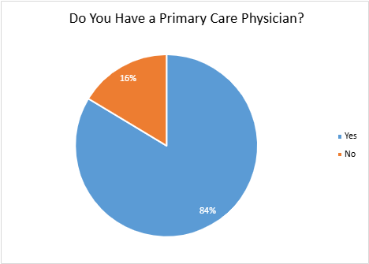

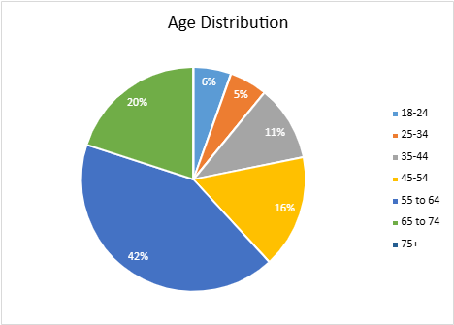

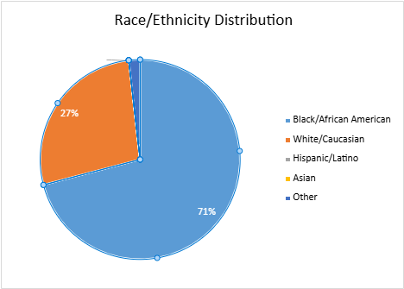

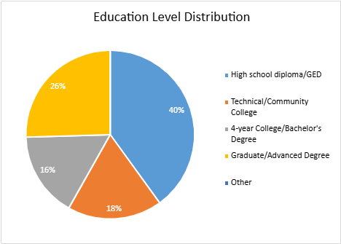

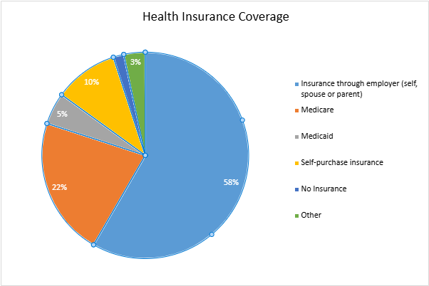

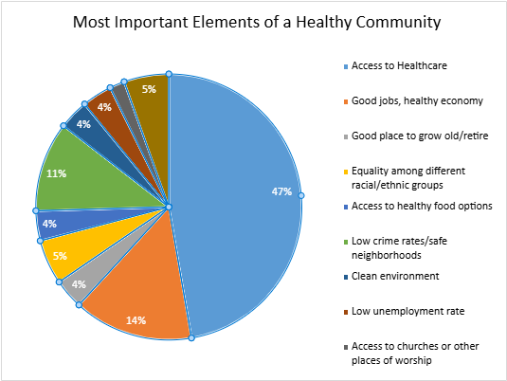

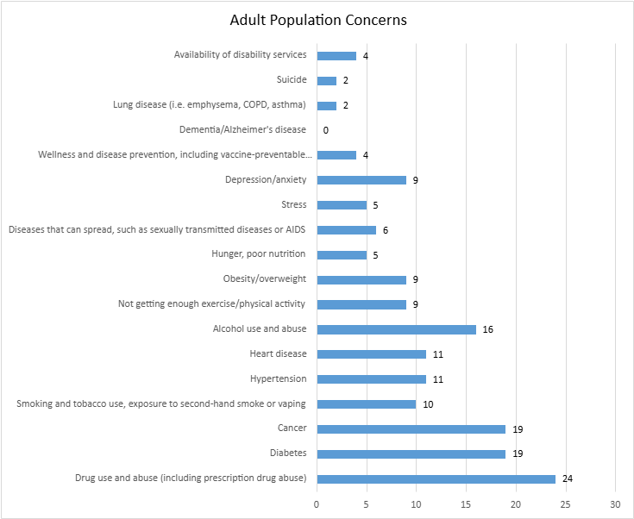
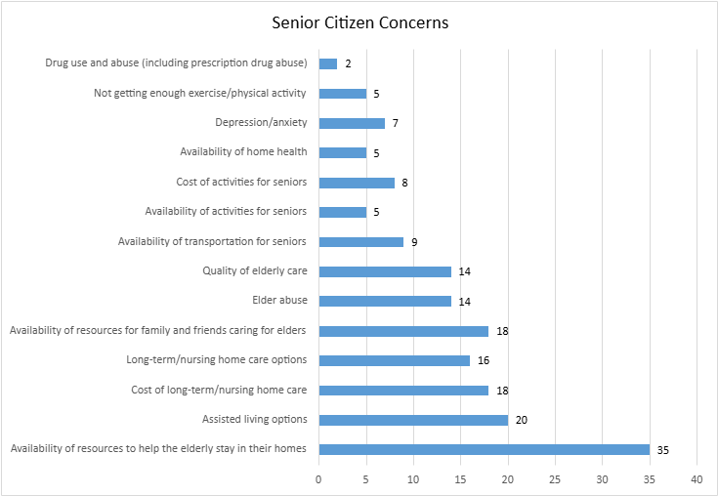

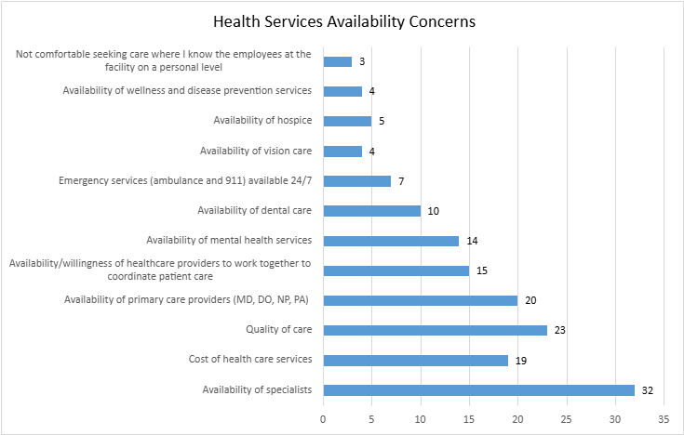

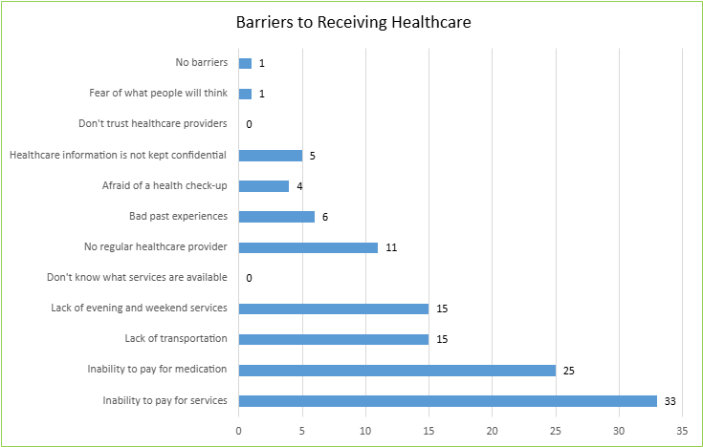

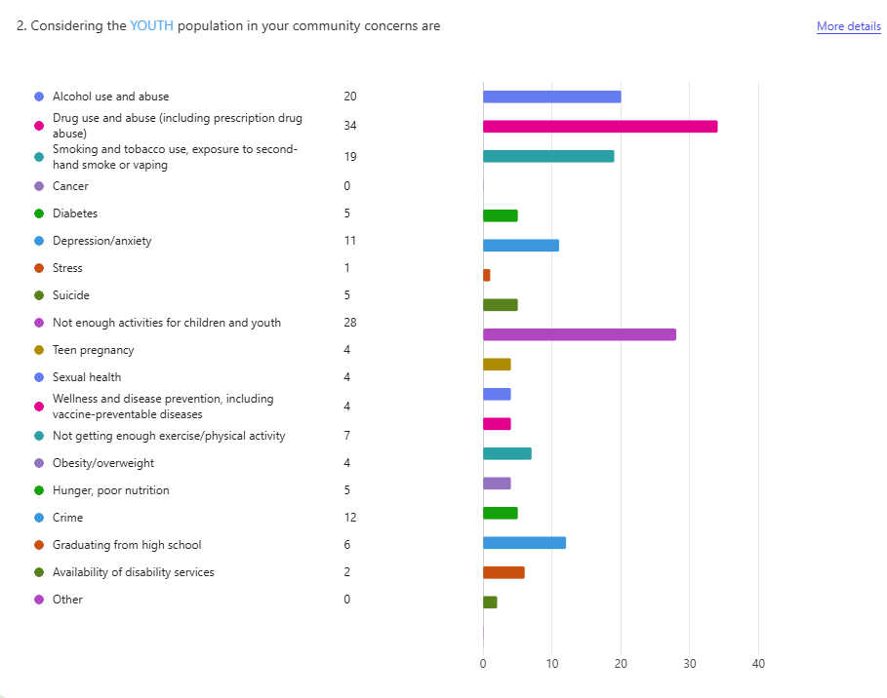

Strategic Initiatives to Enhance Care:
Continue to enhance or expand access to care with primary care and specialty care initiatives such as:
- Sunflower-Greenwood Rural Health Clinic-Greenwood, MS
- Sunflower-Greenwood Pharmacy-Greenwood, MS
- Sunflower-Greenwood Durable Medical Equipment-Greenwood, MS
- Sunflower Clinic-Boyle, MS
- Expand provider coverage with additional provider on-boarding, expanded primary care offerings and with specialty provider collaboration.
- Sunflower Pulmonary Clinic with full-time Pulmonologist
- Jackson Heart Expansion with on-campus days for cardiology

- Enhance process flow within facility and expansion of Tele-Health services.
- Additional collaboration with specialty providers to provide clinics on campus.
- Sunflower Pulmonary Clinic with full-time Pulmonologist
- Jackson Heart Expansion with on-campus days for cardiology

- Enhance our private pay system to allow easier access to available financial assistance programs.
- Expand education to providers and patients on the financial benefits available with the 340-B medication program.

References:
Mississippi State Department of Health (2025). Chronic Disease. Retrieved on the internet from: Mississippi Public Health Report Card 2023 - Mississippi State Department of Health
Federal Poverty Level (FPL) - glossary. Federal Poverty Level (FPL) - Glossary | HealthCare.gov. (n.d.). Retrieved September 13, 2022, from https://www.healthcare.gov/glossary/federal-poverty-level-fpl/
Samuelson, K. (2017, May 4). The role of hospitals in community and Economic Development. The Role of Hospitals in Community and Economic Development | Fels Institute of Government. Retrieved September 2, 2022, from https://www.fels.upenn.edu/recap/posts/1071
Sunflower County, MS. Data USA. (n.d.). Retrieved September 13, 2022, from:
https://datausa.io/profile/geo/sunflower-county-ms
University of Wisconsin Population Health Institute (2022), County Health Rankings & Roadmaps. Retrieved from the internet on November 12, 2022 from: info@countyhealthrankings.org

Information Compiled by Steering Committee Members:
Samuel Miller, DNP, RN, CENP, NHA, REMT-P

Joanie Perkins, CCO
NSMC –Chief Compliance Officer
Patrick Crum, CIO
NSMC Chief Information Officer

NSMC Steering Committee Members:
Daniel Ceja, Chief Executive Officer
Samuel Miller, DNP, RN, CENP, NHA, REMT-P
Joanie Perkins, Chief Compliance Officer
Brooks Rizzo, FNP-BC, CRHCP -Chief Operations Officer
Patrick Crum, CIO-NSMC Chief Information Officer

Ernie Scarber, Community Member-Reviewer

